Come join us and learn about:
The importance of avoiding harmful chemicals in your products
What chemicals to be aware of in the products you use
decreasing your family’s toxic burden
going easy on the earth
an alternative product line
how these products effect your family’s health
Thursday May 28th @7pm

Hosted by: Friends of Taft Public Library
At Mendon Senior Center

Presented by: Jessica Palumbo –
Executive Independent Consultant for Ava Anderson Non Toxic
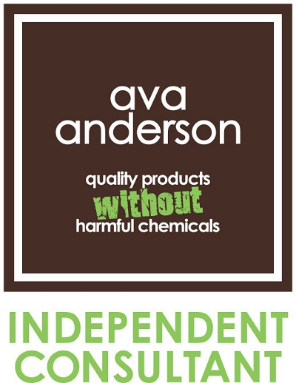

Bring your products from home and become your own ingredient detective! Shop the safest full line of products in the country!

up to 30% of sales will be donated to
the Friends of the Taft Library Relocation Fund

