Cow Chip Bingo
Raffles
Food
Trucks
Hosted By:
The Friends of the Taft Public Library
To Support the Library Relocation Project
FACE
PAINTING

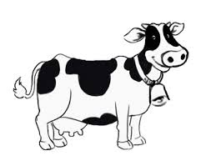
Petting
Zoo
…And
Much, Much
More
November 7, 2015
10:00 – 2:00
CASH PRIZES

1st Prize: $1000
Sponsored by:
M. Del Vecchio Construction

2nd Prize: $500
Sponsored by:
Gliese 623B

3rd Prize: $250
Sponsored by:
Deluxe House of Pizza

(rain date: November 8)
Veterans Park, Mendon, MA
GET YOUR
BINGO
SQUARES
TODAY

$10 PER SQUARE
For a complete listing of
Where to buy
Bingo Squares
Visit www.taftpubliclibrary.org
Or call
508-473-3259

Additional Event Sponsors

Bark Ark
Bee Lines Pavement Marking
Blackstone Valley Shipping Center
BVT Painting & Design Department
C.M. Allaire & Sons/Real Log Homes
Chick-fil-A
Certified Sales, Inc.
Dean Warehouse
Feeds N’ Needs
Fourth Generation Nursery
Franklin Family Karate Center
Greener Acres Farm
Hide-a-Way Pizza
Katydid Flowers
Mendon General Store
Mendon Greenhouse and Florist
Mendon Parks Department
Mendon Wine & Spirits
Nipmuc Landscape
SignsPlus
The Boston Tea Cake Company

