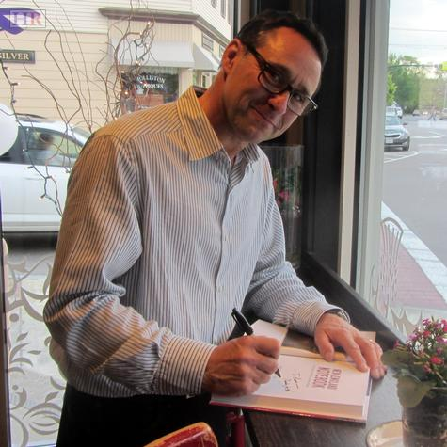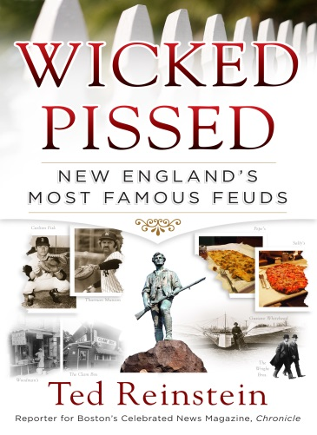

**WCVB Chronicle’s Ted Reinstein**

**Returns to Mendon**

**Tuesday, May 24th at 7pm**

The Taft Public Library is proud to welcome back Ted Reinstein. The event will be held in the Mendon Senior Center. No registration is required.

Ted will talk about, and sign copies of his newest book --

*Wicked Pissed: New England’s Most Famous Feuds*.

Which New Haven pizzeria serves the best slice? Which Route 133 restaurant can boast the best fried clams? Which city, Lexington or Concord, can rightfully claim to be the birthplace of American liberty? Were the Wright Brothers or Gustave Whitehead first in flight? Questions like these and the feuds they’ve ignited are at the heart of Ted’s book. Food rivalries, sports rivalries, family feuds – the stories are plentiful in *Wicked Pissed*.

Ted Reinstein has been a reporter, producer and occasional anchor for WCVB-TV Channel 5’s *Chronicle*, Boston’s long-running, award-winning nightly newsmagazine, since 1995 and sits on WCVB’s editorial board as a contributor. He also provides reports and commentary for WCVB’s *On the Record*, a Sunday morning roundtable show that addresses political issues of the week and he writes a weekly web column, *And Another Thing*. Elsewhere on television, Reinstein hosted *The Popular Mechanics* show on the Discovery Channel and *Lighthouses* for HGTV. On the Travel Channel’s *Freeze Frame*, he landed on top of Hawaii’s Kilauea Volcano, explored caves in Puerto Rico, and swam with sharks in Tahiti. In 2002, he received a prestigious National DuPont-Columbia Award for *Chronicle*’s coverage of “Beyond the Big Dig.” In 2010, he was one of five national finalists in the Washington Post’s annual “Next Great American Pundit” competition. He is a frequent opinion columnist for Boston’s Metrowest Daily News and has written op-ed pieces for The Boston Globe. Reinstein’s first book, *A New England Notebook*, was published in 2013 and was subsequently selected by National Geographic Traveler as one of its “Best Picks” for that year.