Blogging - The 411 on Blogging 101

Meet the Blogger
#girlboss - Bloggers Share Tips for Beginners

The Friends of Taft Public Library are pleased to host Caitlin Lee, college professor, super-momma, beloved wife, and blogger for a local parenting magazine and casual blogger to share information in a fun & interesting way, to lead a forum on blogging ~ what is , blogging, how do you start, why should you do it, who is your audience?...
Join US!
Thursday, January 11, 2018
6:30 p.m. - 7:30 p.m.
Don't Miss the Opportunity to Speak with Caitlin!
Register Today

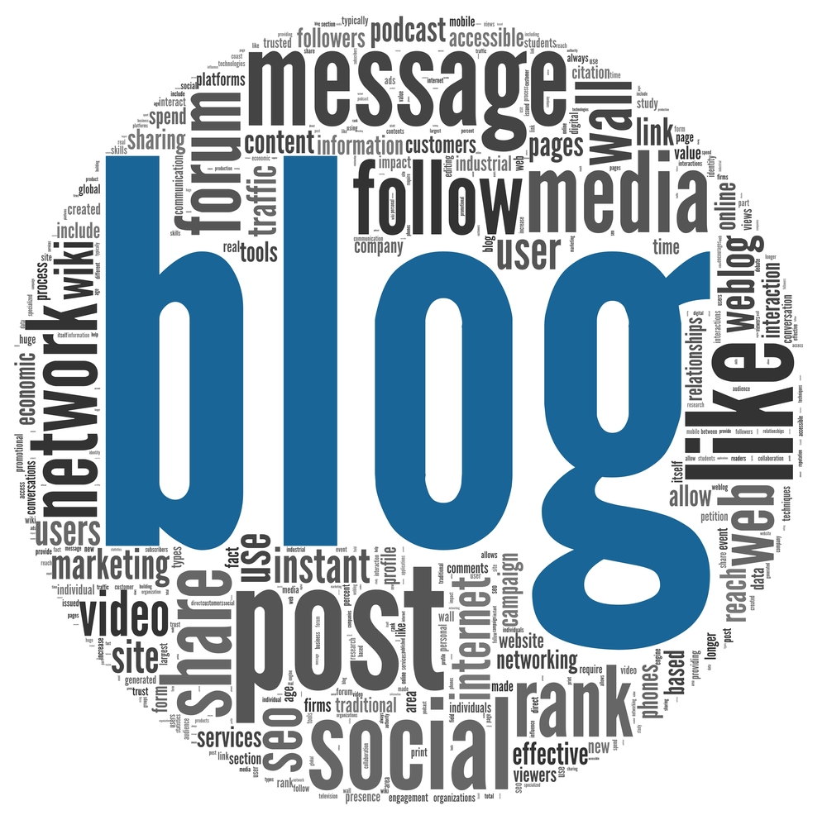

Blogging has quickly become one of the most popular ways of communicating and spreading information & news.

Blogging can help you become a better person & better writer.

Blogging is a great way to express yourself & share information with others.

