[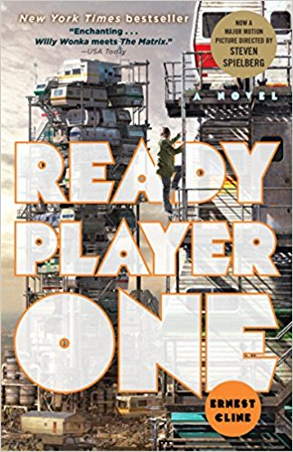](https://www.google.com/url?sa=i&rct=j&q=&esrc=s&source=images&cd=&cad=rja&uact=8&ved=0ahUKEwiB29T7293ZAhUxm-AKHV3wDUwQjRwIBg&url=https://www.amazon.com/Ready-Player-One-Ernest-Cline/dp/0307887448&psig=AOvVaw0cDYTtJRf0-mq2smZGCj1u&ust=1520632425635495)Our Taft Teen Read for April!

Read the book and see the movie!

Pick up a copy of Ready Player One by Ernest Cline at the upstairs desk. Sign up for the movie the night of Friday, April 6th and the book and movie discussion on Thursday, April 12that 5pm. And, get this, the library will cover the cost of the movie!

Teen Book Club is for anyone age 12 or up. (Please note: The movie Ready Player One is PG-13.) Pizza and refreshments will be provided at the book and movie discussion.